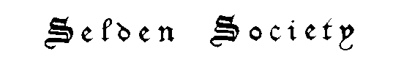
Charity 211536

Form of Application for Personal Membership

To: Secretary, Selden Society,
Laws Building, Queen Mary, University of London
Mile End Road, London E1 4NS

I wish to become a member of the Selden Society.

I send you herewith the following:

a payment of £35 sterling as the present year’s subscription

TITLE………………………………………….………..………………………….

NAME……………………………………………………………………………...

ADDRESS…………………………………………….……………………………

……………………………………………………...……………………………..

email address………………………………………………….

DATE……………………………………………….

Cheques should be made payable to “Selden Society”.

